CK13N -

Functionality
You can see the results of the saved material cost estimate. From here, you can call the reports for analysis purposes.

Scenario
You want to display & analyse cost estimate that you have calculated & saved. You see the costing information, such as BOM, Routing, costing variances etc, and you can see the cost estimates in 3 view: (1) itemization, (2) cost component - primary split view, (3) cost component – process view.

Requirements
Material cost estimate was calculated & saved.

Menu Path | Accounting → Controlling → Product Cost Planning → Material Costing → Cost Estimate with Quantity Structure → CK13N – Display
Transaction Code | CK13N

1. Double click on CK13N - Display.

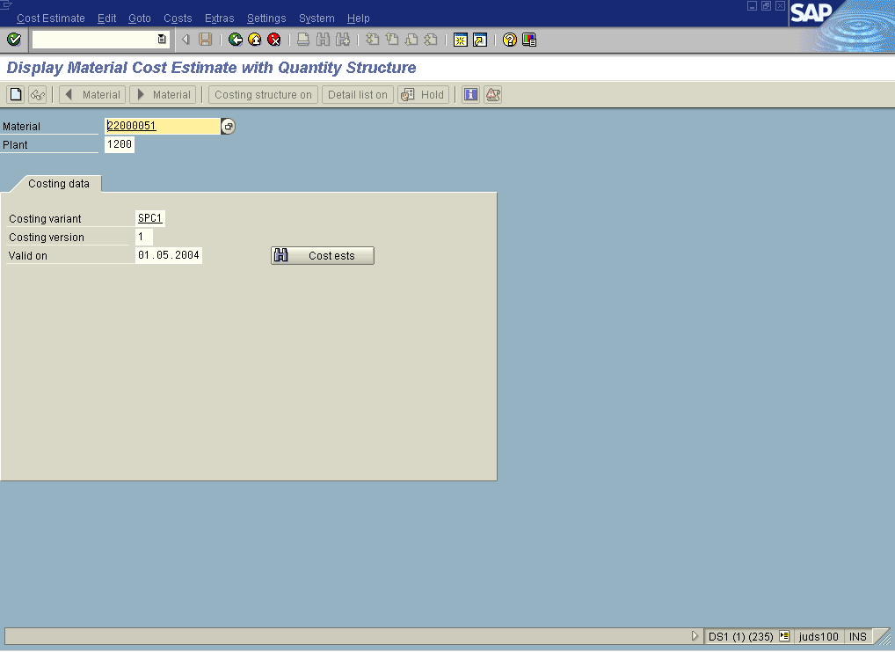

2. Update the following fields:

Field Name | Field Description | Values
Material | Code identifying a product or component | Example: 22000051
Plant | Code identifying the operational unit of the company where the material is manufactured and stored | Example: 1200
Costing variant | Costing variant, i.e. for Legal valuation. | Example: SPC1
Costing version | Costing version, i.e. for mix costing considering different production versions. | Example: 1
Valid on | Date of validity of a cost estimate. | Example: 01.05.2004
3. Click the Enter button.

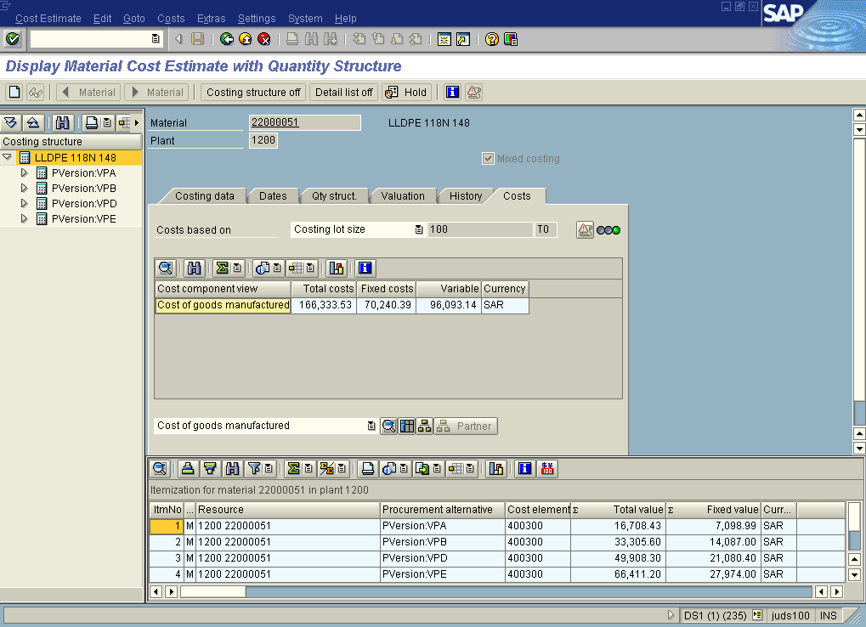

4. Click the Dates tab button.

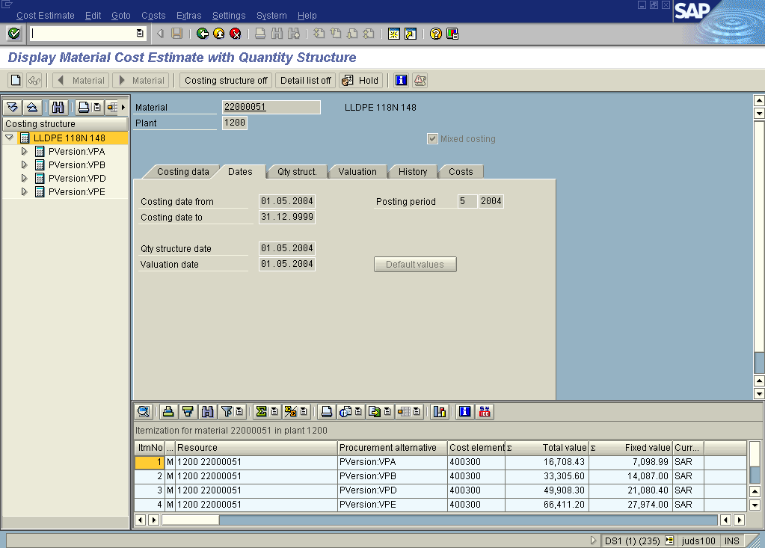

5. Click the Qty struct. tab button.

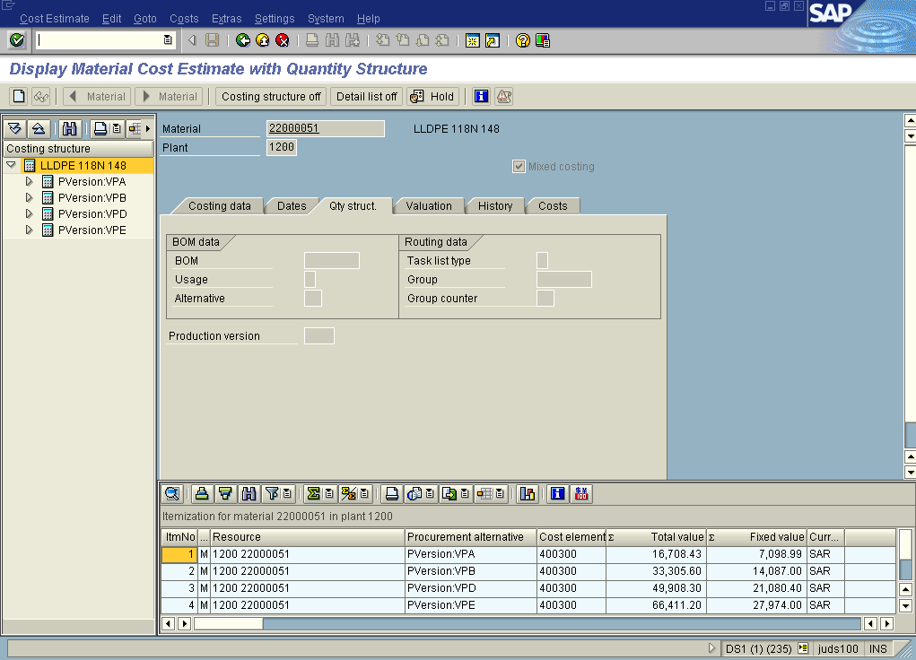

6. Click the Valuation tab button.

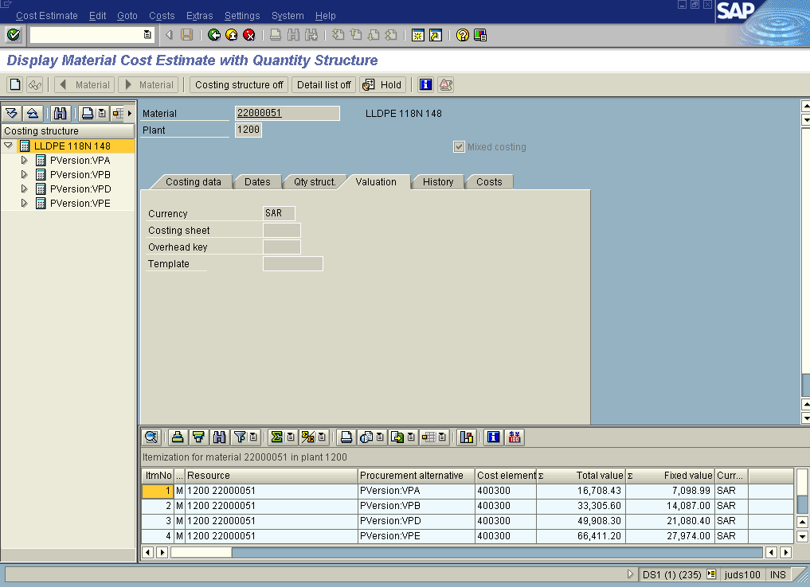

7. Click the History tab button.

8. Click the Costs tab button.

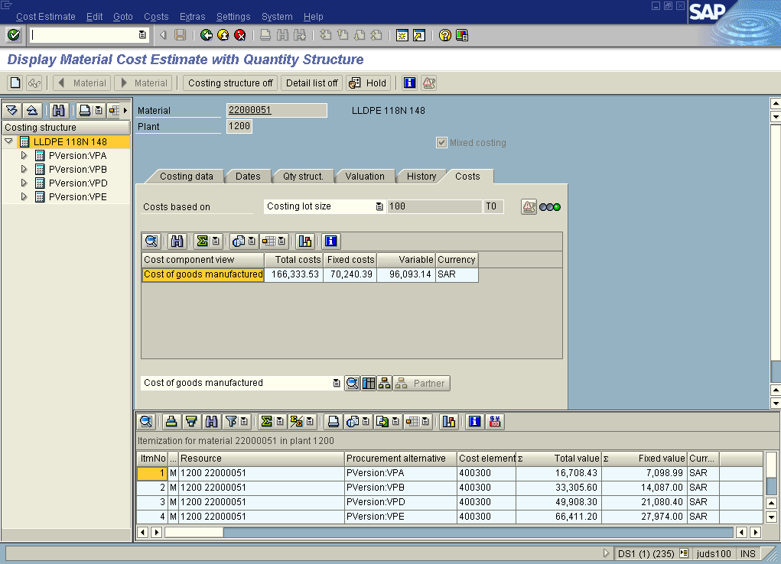

9. Click the List button.

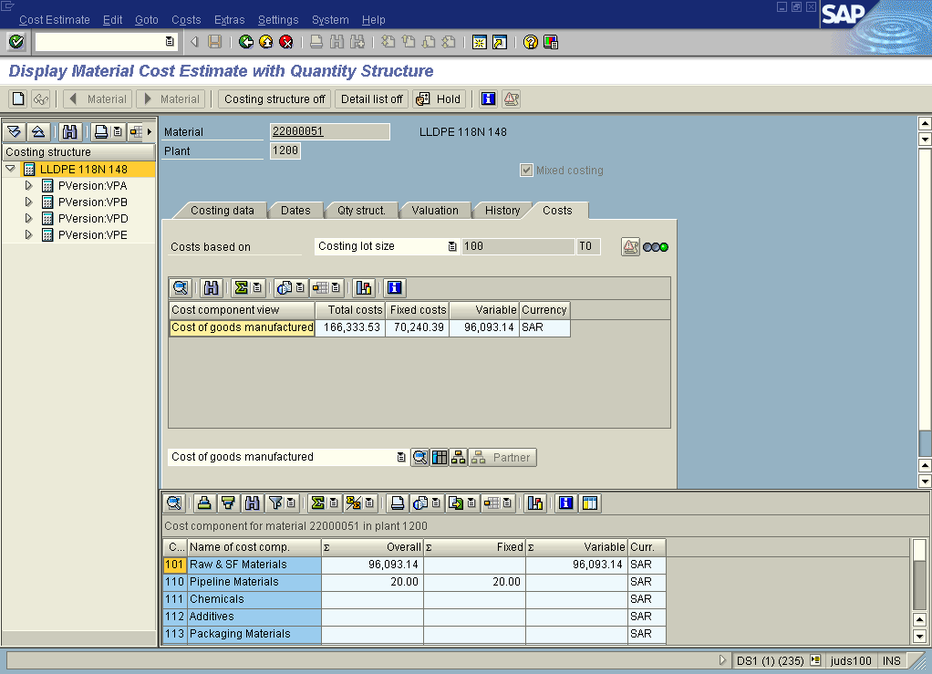

10. Click the Type of Cost Component Split 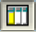 button.

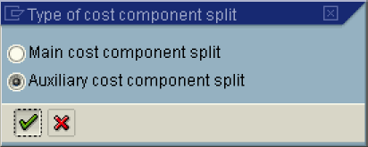

11. Click the Auxiliary cost component split radio button.
12. Click the Continue button.

Display Material Cost Estimate with Quantity Structure

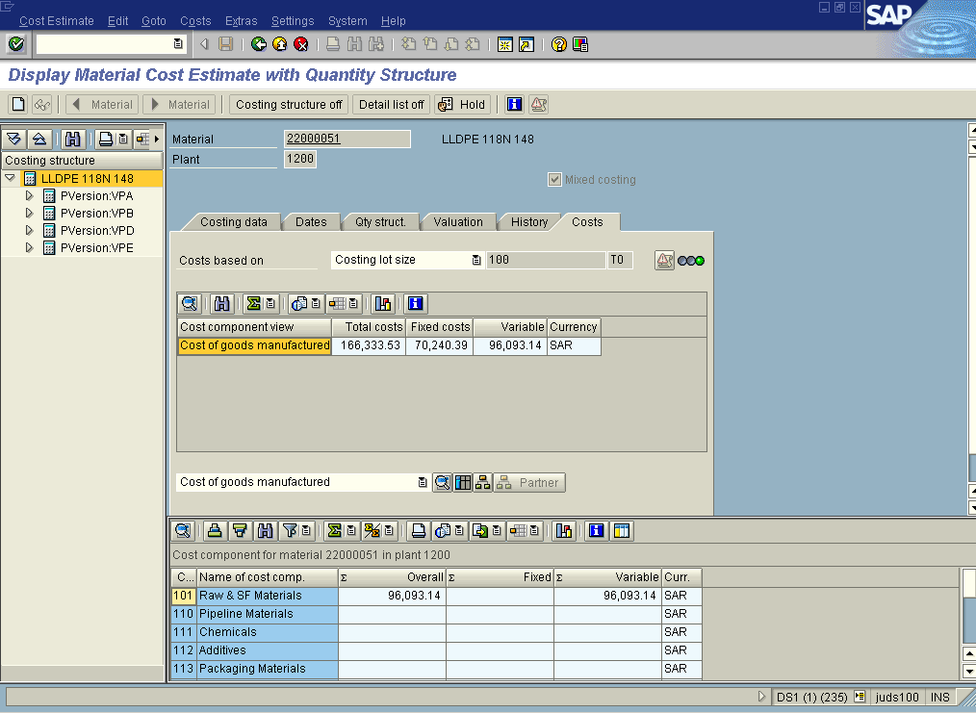

13. Click the Back button.

.

